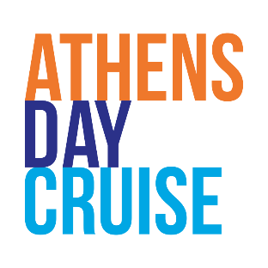

**ATHENS DAY CRUISE DETAILS**

**Cruise Schedule**

Cruise Travel Dates: 13 Jul 2025

Cruise Ships: COSMOS or PLATYTERA TON OURANON

Departure port: Marina Delta Kallithea

Embarkation Time: 7:00 7:30

Departure Time: 7:45

Return time: 19:40

Port of Calls

HYDRA: 1 hour & 50 min stay

POROS: 50 min stay.

AEGINA: 2 hours stay.

**SPECIAL GROUP RATE €112.00**

Cruise Ticket Includes

Departure from Marina Delta Kallithea.

Visit to three beautiful islands of Saronic Gulf, Hydra Poros Aegina.

Lunch Buffet on board.

Live music and folklore show for entertainment.

Port Taxes.

* Kindly consider that the cruise timetable is on an estimated basis.

Evermore Cruises & Hydraiki N.C. organizes unique Daily Cruises boarding from Athens to Hydra, Poros & Aegina.

Enjoying sun, sea & entertainment.

The daily cruise in three magical Greek treasures, Hydra, Poros and Aegina, across theChoice Awards Winner 2023 & 2024 & our Certificate of Excellence 2015, 2016, 2017, 2018, 2019 of Tripadvisor recommended our services.

Get on board and experience the harmonious combination of Greek hospitality and multicultural co-existence. A big group of people of different nationalities, customs, and cultures, along with the unique Greek hospitality and entertainment, will travel like never enjoying the sun, our tasty foods, and delicacies.

Port of Calls & Highlights

The Cosmopolitan HYDRA with its cobblestone alleys, its unspoiled over the centuries -unique architectural beauty, as well as the traditional means of transportation that you can find on the island, its donkeys, will make the visitors fall in love with it at first sight. Enjoy a walk and discover the historic landmarks.

Leafy island POROS, with an insuperable natural beauty and thousands of lemon trees, expands from the steep and sandy beaches, making the romance and calmness island.

The historical AEGINA, which took its name by the beautiful nymph that, was kidnapped by Zeus. Aegina is well known worldwide for its delicious pistachios, beautiful beaches, the Temple of Aphaia, and St. Nektarios Cathedral.

Additionally, our guests could book transportation, breakfast on board, and optional excursions to the islands (extra charge). Our company organizes shore excursions in Hydraand Aegina (optional). The shore excursions include:

a) Hydra Walking Tour, b) the experience of the Ancient Temple of Aphaia and the Greek Orthodox Cathedral of St. Nektarios in Aegina, c) the Panoramic Tour in Aegina by bus and d) a Swimming escape in Aegina, e) Aegina Walking Tour.